# Upscaling DPV droop response

## Motivation

The DER-DAT Tool identifies if each circuit within the SolarAnalytics DPV dataset is compliant with its droop response. *Upscaling* is used to predict the total MW curtailment due to droop response in a region based off the performance observed in the SolarAnalytics DPV dataset.

## Droop Compliance

Under AS4777.2:2015 and AS4777.2:2020, an inverter is ‘droop compliant’ if they correctly respond to an over frequency event and curtail their output. The duration and amount of curtailment depends on the observed frequency and Standard.

The inverter will provide a linear droop response:

The tool characterises droop under a few categories:

| **Droop response** | Definition |
| --- | --- |
| Responding as specified | DPV systems reduced power by at least 50% of the specified reduction for the whole response period. |
| Partially responding | DPV systems reduced power by at least 50% of the specified reduction for at least one measurement interval in the first two minutes. |
| Not responding | DPV systems did not demonstrate a significant reduction response. |
| Disconnect | DPV systems that reduced output power to less than 5% of the pre-event power for at least one measurement interval during the response period. |

Note that the ‘response period’ differs for inverters installed on the 2015 and 2020 Standards respectively.

## The upscaling script

### How to use the script

1. Enter user defined parameters at the top of the script (the parameters are described below)
2. Enter the file locations for the Underlying and CER datasets
3. Enter the file directory you want to output results
4. Make sure the source(upscale_fw_functions.R) are pointed at file location
5. Click run
6. Graph the csv in excel or any other software to extract MW responses for each Standard and droop response

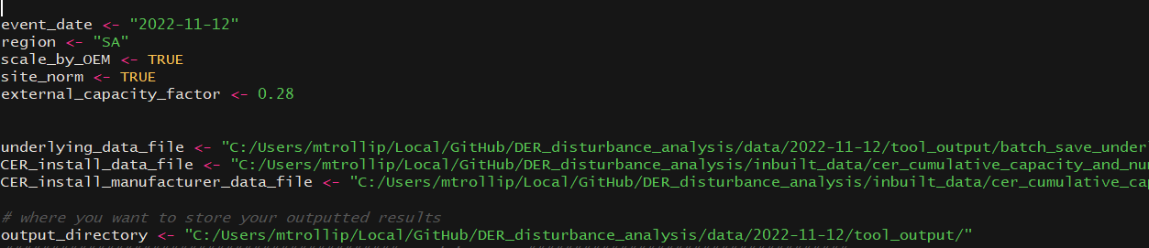

Figure 1: Adding parameters

### What does the script do?

The upscaling script:

**Input:** The underlying data of an over-frequency event, CER manufacturer installation data and CER standard installation data.

**Output:** Upscaled MW profile for each droop response category and Standard as a csv. See Figure 2 for an example of a trace of the output plotted in excel.

Figure 2: Example output of script, graphed in excel

## 

### How does it upscale?

This section outlines the steps taken to upscale

|  |  |
| --- | --- |
| **Step** | **Description** |
| 1. Read in data | The underlying data is read in. |
| 1. Process data | The underlying data is processed so that it is ready for upscaling. |
| 1. Get response proportions | Gives the proportion of circuits with a particular droop response of a given OEM and Standard.    Note that the sample size refers to the total number of circuits with the same manufacturer (OEM) and Standard. While the count is the number of circuits for a given droop response of that particular OEM and Standard |
| 1. Get CER capacities | The CER capacities represent the total installed capacities in the NEM. The script extracts the CER capacities for each OEM and Standard of the region of interest (i.e ABB has installed capacity of 10 MW of 2015 Standard in Victoria) |
| 1. Calculate upscale MW profile for each Standard and response type | This gets a MW profile for each class by **first scaling by OEM.** The process is fairly complicated, but in a nushell: Get a normalised power output profile averaged for a given OEM, Standard and Response type. The normalised value is then multiplied by a capacity. The individual OEM traces for a given Standard and response type are summed to provide the upscaled response.  There are 2 options here:   1. Use a ‘site performance factor’ 2. Use an ‘external capacity factor’   The use of an external capacity factor is currently preferred as it uses external data to infer the fleet capacities.  ** Step 5 is explained in detail below |
| 1. Output the MW profile to csv | Outputs timeseries csv. First column is timestamp, remaining columns are the upscaled MW output for each Standard and response type: |

### Step 5 in detail: How the scaling works

There are two options here.

The first method upscales based entirely on the SolarAnalytics dataset, by inferring total upscaled MW output based on a *site performance factor.* The *site performance factor* is the summation of the output of all circuits in a site, divided by the sites installed capacity.

The second method uses an external capacity factor instead of the site capacities stored within the SolarAnalytics data to infer the total upscaled MW output. It normalises the power output based on the pre event value. This normalised power output is averaged for circuits of a given OEM, Standard and Response type. The averaged profile is multiplied by the CER installed capacity for the given OEM, Standard and Response type. All the individual OEM profiles are summed for a given Standard and Response type. The summed response is multiplied by an external capacity factor to give the results.

**Option 1: using a ‘site performance factor’**

Getting the site performance factor for each class:

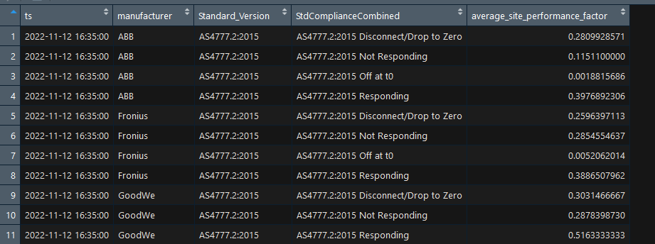

The *site performance factor* is averaged across all sites of a given OEM, Standard and Droop response for each timestamp. This is shown above.

This average is then multiplied by the CER installed capacity for the given class (called the proportion capacity which is calculated in step 3) to give the upscaled MW output for a given OEM, Standard and Class.

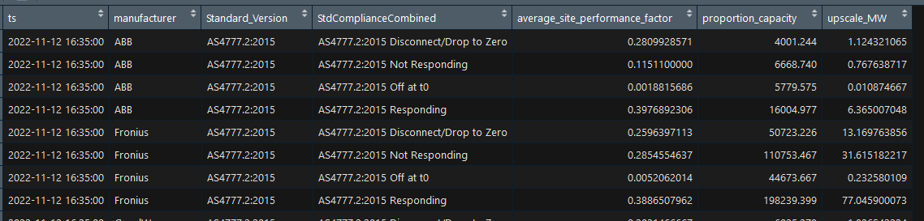

Individual OEM upscaled_MW traces are then summed together to get an upscaled_MW trace for each Standard and droop response

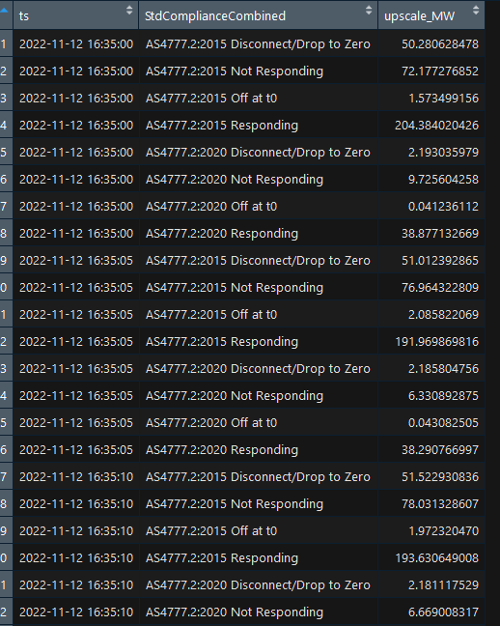

The data is then pivoted to give individual columns to each compliance response

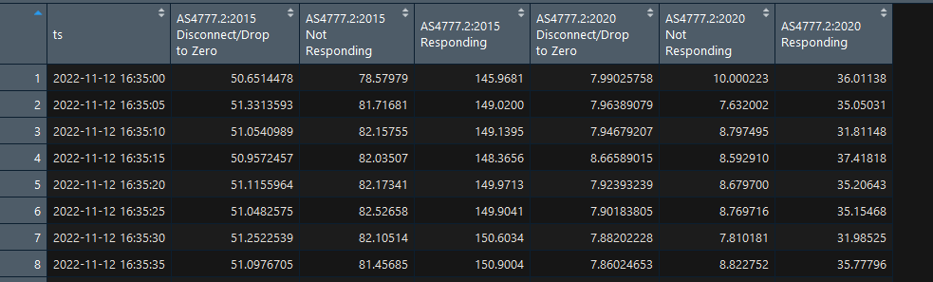

**Option 2: using an external capacity factor**

Individual circuit power traces are normalised based on the pre event output (i.e would give 1 at pre event interval).

The circuit normalised power traces are averaged for each OEM, Standard and response type:

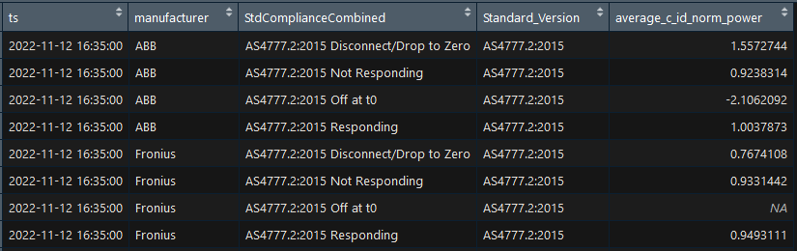

For instance row 1 shows the average normalsied circuit output power for all ABB, 2015 Standards that Disconnected/Dropped to Zero following the disturbance.

The average_c_id_norm_power is then multiplied by the CER installed capacity for the given OEM, Standard and Response type.

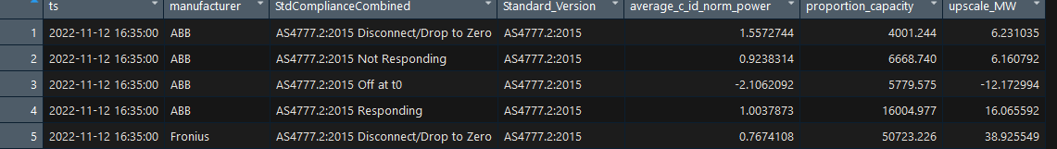

Note above^ that ‘proportion capacity’ refers to the CER installed capacity for the given OEM, Standard and Response type.

The upscaled_MW profile is then added across all OEMs for a given Standard and Response

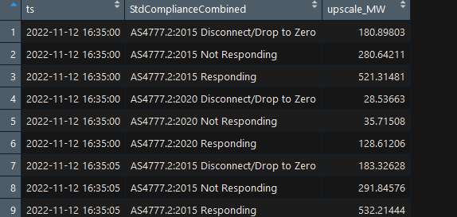

Note however, that upscaled_MW values directly above would only be correct if the fleet was operating at 100% capacity (i.e all inverters were outputting their maximum). This is because we have multiplied the total capacity with the normalised response, where the normalised response is 1 or 100% at the interval before the disturbance.

Hence we need to multiply by an external capacity factor to correctly represent the upscaled MW profile.

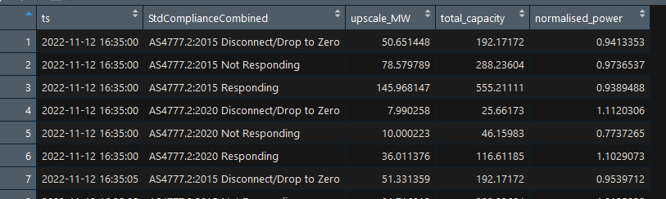

Here the upscaled MW has now been multiplied by the capacity factor. In this example the capacity factor was 0.28.

Hence looking at the first row of the previous two images, we get 180.9 MW * 0.28 = 50.7 MW.

The results are then pivoted to give individual columns for each Standard and Response type